* 1. Describe cloud computing
     1. Define cloud computing
        1. Cloud computing refers to the use of hosted services, such as data storage, servers, databases, networking, and software over the internet.
        2. The data is stored on physical servers, which are maintained by a cloud service provider.
           1. 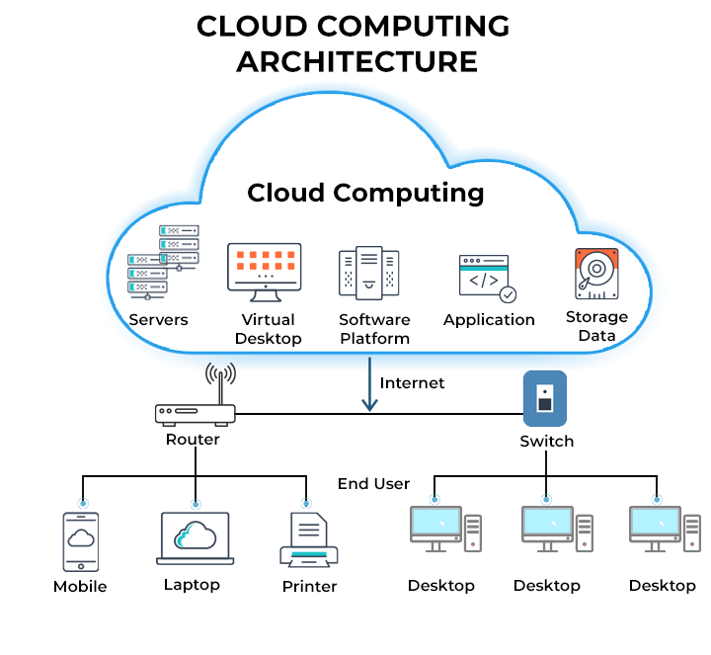

* 1. Describe the shared responsibility model

Responsibility 
Information and data 
Responsibility always 
Devices (Mobile and PCs) 
retained by the customer 
Accounts and identities 
Identity and directory infrastructure 
SaaS 
PaaS 
laaS 
prem 
Responsibility 
varies by type 
Responsibility transfers 
to cloud provider 
Applications 
Network controls 
Operating system 
Physical hosts 
Physical network 
Physical datacenter 
Microsoft 
Customer 

* 1. When using a cloud provider, you’ll always be responsible for:
     1. The information and data stored in the cloud
     2. Devices that are allowed to connect to your cloud (cell phones, computers, and so on)
     3. The accounts and identities of the people, services, and devices within your organization
  2. The cloud provider is always responsible for:
     1. The physical datacenter
     2. The physical network
     3. The physical hosts
  3. Your service model will determine responsibility for things like:
     1. Operating systems
     2. Network controls
     3. Applications
     4. Identity and infrastructure

* 1. Define cloud models, including public, private, and hybrid

|  |  |  |
| --- | --- | --- |
| Public cloud | Private cloud | Hybrid cloud |
| No capital expenditures to scale up | Organizations have complete control over resources and security | Provides the most flexibility |
| Applications can be quickly provisioned and deprovisioned | Data is not collocated with other organizations’ data | Organizations determine where to run their applications |
| Organizations pay only for what they use | Hardware must be purchased for startup and maintenance | Organizations control security, compliance, or legal requirements |
| Organizations don’t have complete control over resources and security | Organizations are responsible for hardware maintenance and updates |  |

* 1. Describe the consumption-based model
     1. There are two types of expenses to consider.
        1. Capital expenditure (CapEx) - One-time, up-front expenditure to purchase or secure tangible resources. A new building, repaving the parking lot, building a datacenter, or buying a company vehicle.

* 1. Operational expenditure (OpEx). - Spending money on services or products over time. Renting a convention center, leasing a company vehicle, or signing up for cloud services.

* 1. Cloud computing falls under OpEx because cloud computing operates on a consumption-based model
  2. Benefits of consumption-based model
     1. No upfront costs.
     2. No need to purchase and manage costly infrastructure that users might not use to its fullest potential.
     3. The ability to pay for more resources when they're needed.
     4. The ability to stop paying for resources that are no longer needed

* 1. Compare cloud pricing models
     1. Cloud computing is the delivery of computing services over the internet by using a pay-as-you-go pricing model.
     2. You typically pay only for the cloud services you use.

* 1. Describe serverless

* 1. Describe the benefits of using cloud services
     1. Describe the benefits of high availability and scalability in the cloud
        1. Maximum availability
        2. Scalability is ability to adjust resources to meet demand, we are paying what we use
           1. Vertical scaling is focused on increasing or decreasing the capabilities of resources. - Adding more CPUs or RAM
           2. Horizontal scaling is adding or subtracting the number of resources. - Adding additional Virtual Machines

* 1. Describe the benefits of reliability and predictability in the cloud
     1. Reliability is the ability of a system to recover from failures and continue to function.
     2. With a decentralized design, the cloud enables you to have resources deployed in regions around the world.
     3. Performance and cost predictability are heavily influenced by the Microsoft Azure Well-Architected Framework. Deploy a solution built around this framework and you have a solution whose cost and performance are predictable

* 1. Describe the benefits of security and governance in the cloud
     1. Cloud-based auditing helps flag any resource that’s out of compliance with your corporate standards and provides mitigation strategies
     2. Depending on your operating model, software patches and updates may also automatically be applied, which helps with both governance and security

* 1. Describe the benefits of manageability in the cloud
     1. Management of the cloud
        1. Automatically scale resource deployment based on need.
        2. Deploy resources based on a preconfigured template, removing the need for manual configuration.
        3. Monitor the health of resources and automatically replace failing resources.
        4. Receive automatic alerts based on configured metrics, so you’re aware of performance in real time.
     2. Management in the cloud
        1. Through a web portal.
        2. Using a command line interface.
        3. Using APIs.
        4. Using PowerShell.

* 1. Describe cloud service types
     1. Describe infrastructure as a service (IaaS)
        1. Lift-and-shift migration: You’re setting up cloud resources similar to your on-prem datacenter, and then simply moving the things running on-prem to running on the IaaS infrastructure.
        2. Testing and development: You have established configurations for development and test environments that you need to rapidly replicate. You can start up or shut down the different environments rapidly with an IaaS structure, while maintaining complete control.

* 1. Describe platform as a service (PaaS)
     1. Development framework: PaaS provides a framework that developers can build upon to develop or customize cloud-based applications.
     2. Analytics or business intelligence: Tools provided as a service with PaaS allow organizations to analyze and mine their data, finding insights and patterns and predicting outcomes to improve forecasting, product design decisions, investment returns, and other business decisions.

* 1. Describe software as a service (SaaS)
     1. Email and messaging.
     2. Business productivity applications.
     3. Finance and expense tracking.